CIS11 Course Project Part 2: LC-3 Program
In Part 2, we will create an LC-3 program that apply learned concepts in the course. This project is designed to capture the primary concepts of the course, which consist of computer architecture, processing and assembly programming. The program must fulfill the technical requirements. Refer to below project requirements.

Tasks:
- Review program requirements, pseudocode (from part 1) and flowchart (from part 1).
- Write an LC-3 program that meets the requirements based on the given project options.
- Test and analyze the program outcome to assess program limitations, performance, efficiency and future improvements.
- Submit LC-3 program (.asm file).

Project Program Requirements:

Option C: Character Counter for Names
Program
Create an LC-3 program that displays the frequency of characters of user full name.
Input: User is prompt to input his or her full name.
Output: Numerical value the represent the frequency of a character in the user fullname.
The program must fulfill the following criteria:
- Contain appropriate addresses: origination, fill, array, input and output. (20 points)
- Display counted values in console. (20 points)
- Use appropriate labels and comments. (20 points)
- Contain appropriate instructions for arithmetic, data movement and conditional operations. (40 points)
- Comprise of 2 or more subroutines and implement subroutine calls. (20 points)
- Use branching for control: conditional and iterative. (30 points)
- Manage overflow and storage allocation. (20 points)
- Manage stack: include PUSH-POP operation on stack. (20 points)
- Include save-restore operations. (30 points)
- Include pointer (20 points)
- Implement ASCII conversion operations (30 points)
- Use appropriate system call directives. (10 point)
- Testing (20 points): Test the program using the team names.
Building and testing the program is for Project Part 3 (Total 300 points).

Test 1
Input: Justin Sweers
Output:
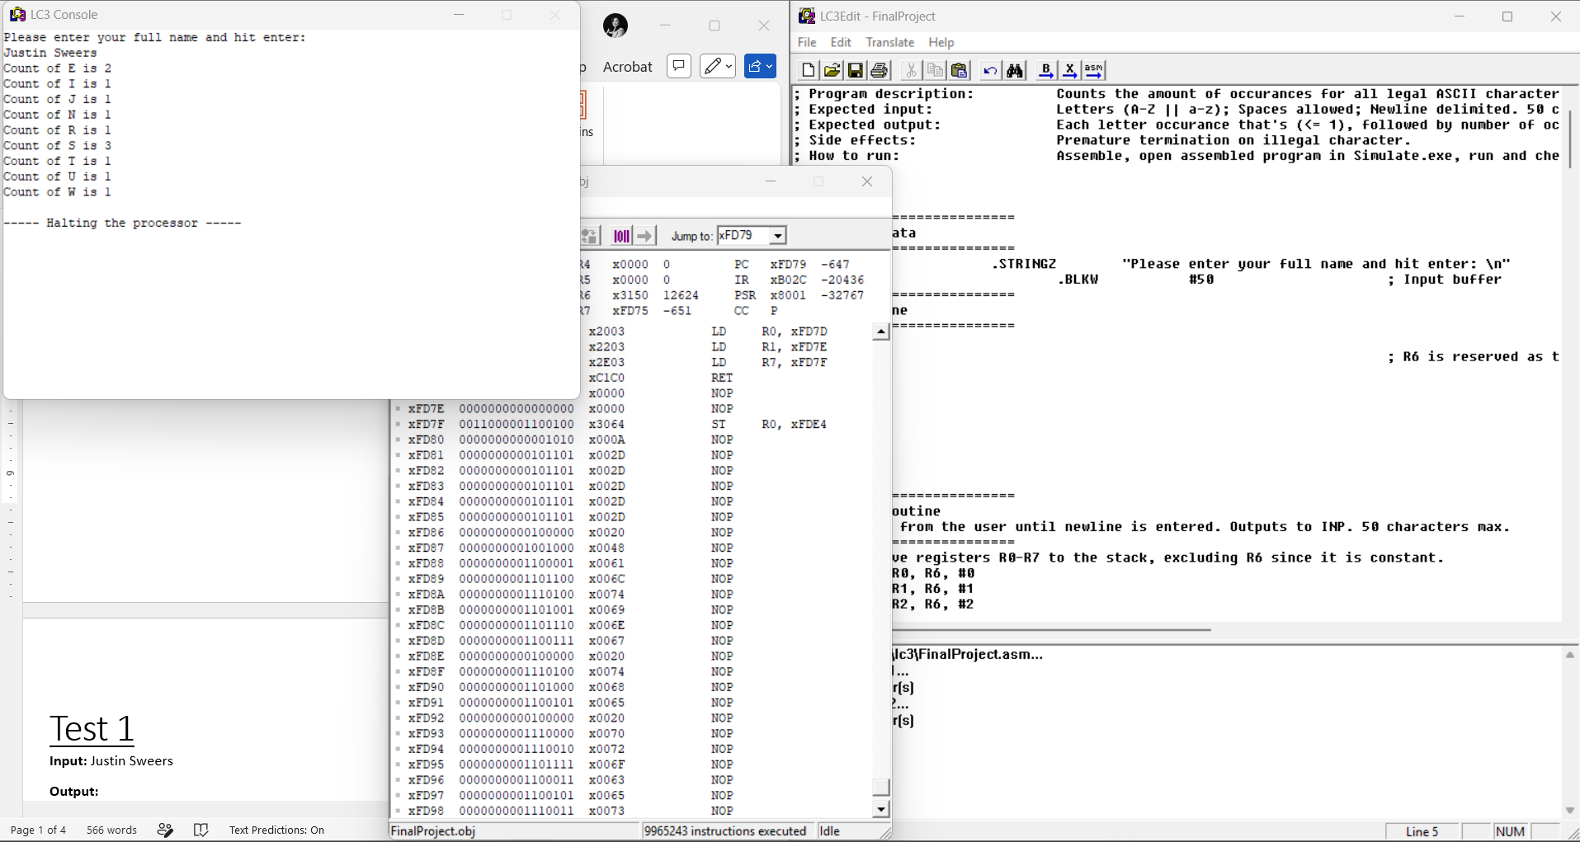
Result
The program successfully accepted the user input and displayed the frequency count for each character in the full name. Repeated characters such as “S” and “E” were counted correctly, while spaces were ignored. The output was displayed in the console without any assembly or runtime errors.

Analysis
This test confirmed that the program correctly handles uppercase and lowercase character conversion, stores user input into memory, loops through the characters, and updates the frequency array properly. The program also demonstrated successful use of branching, subroutines, and ASCII conversion operations.

Test 2
Input: Keanu Arao
Output:
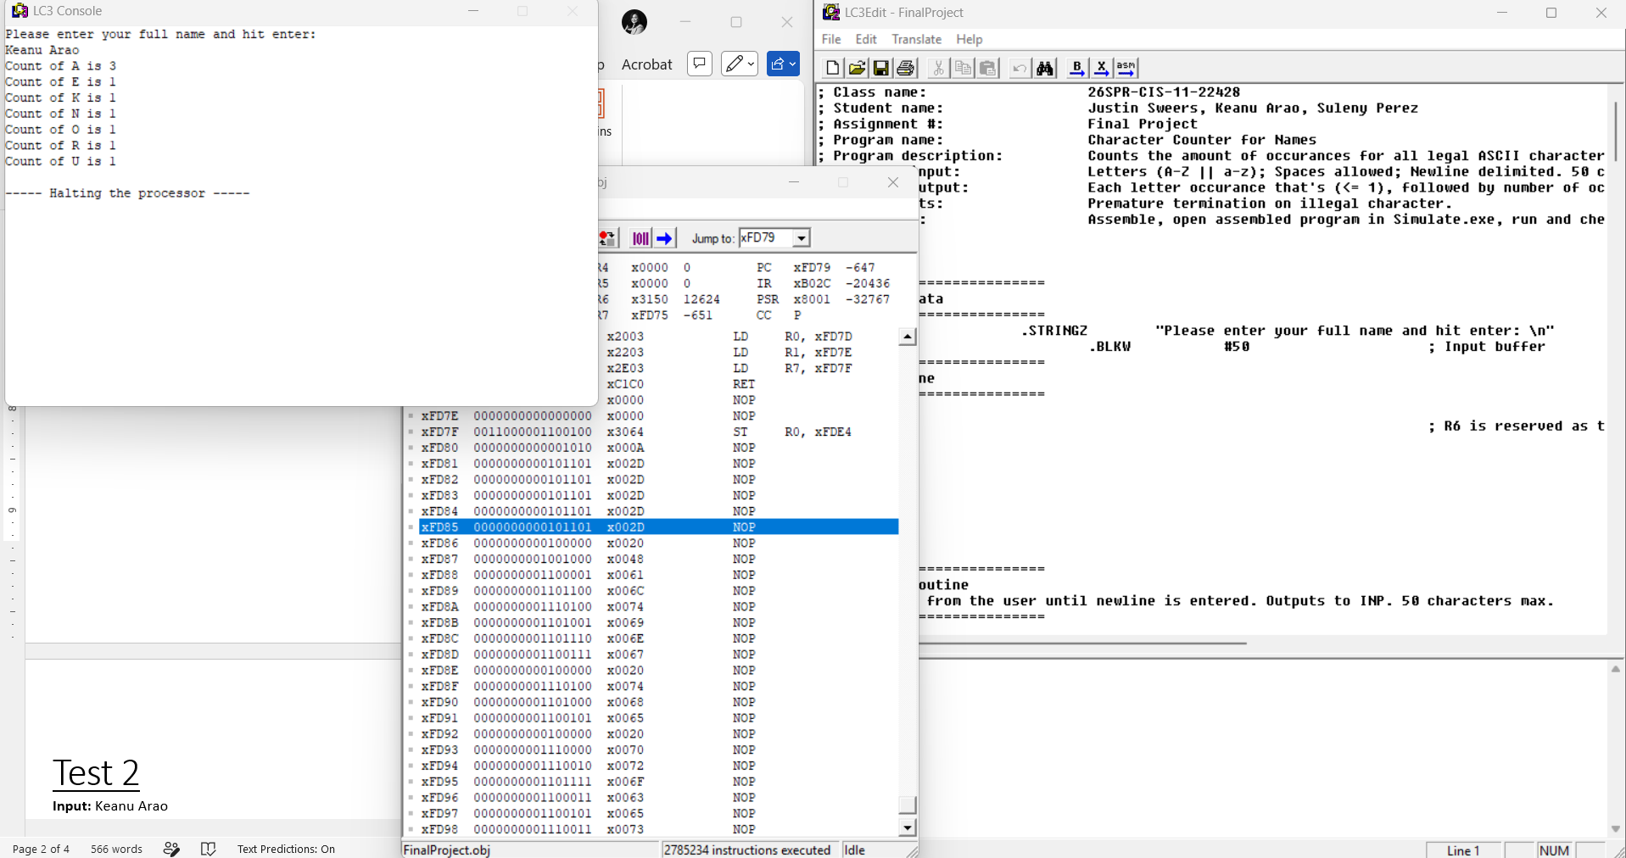
Result
The program successfully processed the full name input and displayed the correct character frequency counts in the console. The repeated character “A” was counted accurately three times, while all other letters were counted correctly and displayed without errors.
Analysis
This test verified that the program correctly handles repeated characters, loops through the stored input, and updates the frequency array appropriately. The program also demonstrated proper branching, memory storage allocation, subroutine calls, and ASCII conversion functionality during execution.

Test 3
Input: Suleny Perez
Output:
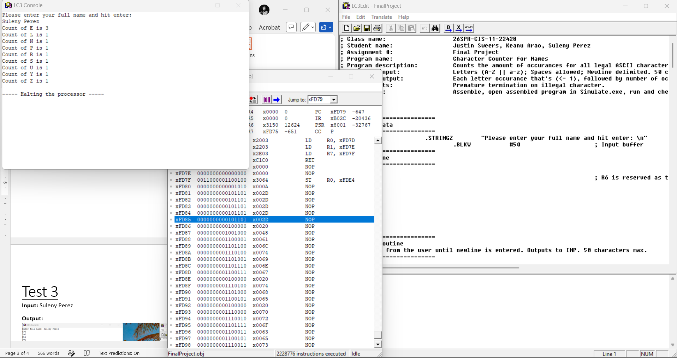
Result
The program successfully accepted the user’s full name and displayed the correct character frequency count in the console. The repeated character “E” was counted properly, and the space between the first and last name was ignored during processing.
Analysis
This test demonstrated that the program correctly stores user input into memory, converts lowercase letters when needed, and counts character frequencies accurately using loops and conditional branching. The output was displayed without assembly or runtime errors, confirming that the subroutines and ASCII conversion operations functioned properly.

